

Programme Name: ________**BCS HONS**_______________________________________

Course Code: __**CSC 2201**_______

Course Name: ________**Human Computer Interaction**______________________________

**Assignment** / Lab Sheet/ Project / Case Study No. _**1**___

Date of Submission: ______**2020/06/12**_____________

**Submitted By: Submitted To:**

Student Name**: Dipesh Tha Shrestha** Faculty Name**: AKASH DEO**

IUKL ID: **041902900028** Department**: LMS**

Semester**: Third Semester**

Intake**: September 2019**

# ​ **​ “Q.NO.1”​**

**Project proposal​**

HamroSoftware

Project title : App development

Project details and description:

We all need mobile application these days. Mobile applications are an integral part of our lives. Without these applications, we all feel like there is something missing in our lives. Mobile applications have bound us in such a way that we are having a tendency to use them as a daily routine. Making a**Mobile App for your school**is a very basic need these days. Because **apps for school education** are very helpful and trends in the education sector

Nowadays these mobile applications are an integral part of the education sector. There are applications available for the schools and colleges which provides a very distinctive knowledge from what they teach in schools. The syllabus available on these apps is quite recommendable and is also very precise when you read it or study it. So having these kinds of application around your kids then they don’t need to worry about missing out on any topic just because they took a leave from the school.

School Mobile Application these days are very much needed as the pressure of studies on kids these days are getting heavier. Nowadays all the teachers, students and their parents need a portal where they all together can view the student’s details. Also, they can compare the student’s results with the past results and can check the performance of the student that they are doing well or not.

In this time of global pandemic, physical appearance in schools is impossible. And this should not be the problem in today’s world because the technologies of this era can solve this problem. But it still remains a challenge and a problem. for most of the schools to adapt with this new style of education. Hence considering the circumstances of this problem, our purpose is to deliver the ultimate solution. While school management software is a useful tool in any educational institution’s arsenal, one can recognize its full worth when using it on a mobile device. The full power of school management software gets unleashed by its suitability to be used on the go, using people’s devices.

Research shows us that most people use mobile devices – like mobile phones or tablets – to access their online portals. In this fast-paced world, a tool like a school management software becomes a right partner in the educational ecosystem when people can use it from anywhere at any time and across their devices. A seamless experience across devices and platforms in this regard is key to increasing usage on a consistent base by various stakeholders in the industry.

The purpose of the project is to execute the complete design and development of a school app for Sunway High School. The cutting edge app will feature all the elements, functions and specifications. Despite the evident complexity and depth of Sunway High School app, the user experience must remain particularly smooth and simple. The design must be high-end, pleasant and clean, creating an atmosphere of confidence and professionalism. Another thing to be considered is to not design the app considering the pandemic because after its over it should still be usable. The problems should be given attention in a very critical way. There are already many apps in the market but the problem with them is very different and basic. Some existing problems are unable to upload assignments files, couldn't record attendance, login problems, question paper easily being accessed by students, difficult interface, etc. So basic problems like these must be given importance and should be avoided at any cost because the project should deliver the solutions to those existing problems. Certain tools and technologies are used in this project, the main being the graphical design work. This technology helps to eliminate the interface related problem totally and gives the user a simple and reliable interface. Optimization is also focused because it makes this app run in low level devices also without any problem. New technology system called User traffic control system is introduced and used in this development which helps in monitoring the user traffic and eliminating traffic problems. The other major technologies used in the development will be W3C, HTML, DHTML, PHP, MYSQL, JavaScript, XHTML, CSS,XML, API and Flash.

**“Q.No.2”​**

Based on the question provided I have tried to discuss the good and bad UI with examples of both types. Here I have chosen the UI of one of the famous social sites. For the good UI, I have chosen Facebook and for the bad UI I have chosen Instagram. And the interpretation is only based when using them from the browser not with the mobile. Further explanation is given below:

**Facebook: Good UI**

I have chosen Facebook as having a good UI because the UI design is very reliable, easy and simple. It can easily be adopted by the people who just created the new Facebook account. It follows some unique design and usability principles. User control and freedom is a unique usability problem it follows which lets users see what they want to see by customizing the page on behalf of their interest. Other than that it follows principles like flexibility and efficiency of use, minimalist design, etc.

**1. Visual Hierarchy for Intuitive Interactions**

The human brain categorizes information by grouping similar visual elements and organizing them into meaningful patterns. Information that is hierarchically organized will be more effective in communication as compared to unorganized information. For web (or app) design, it is important to create distinct sections on the interface to ease the mental organization of related elements. This helps the user focus on important elements, instead of on the information clutter and makes the browsing experience simple and intuitive.

**Example**: Facebook focuses on the News Feed (the main content a user wants to see), which contains all the important updates about what your friends are saying and sharing. On one side, you have a dashboard with your profile details, photos, friends, events, groups, pages, and more, and trending topics, status updates and advertisements and suggestions on the other side.

**2. Appealing Layout for Easier Navigation**

Clear fonts and icon designs help the user navigate better. Examples include an intuitive menu, legible fonts, and well-contrasted backgrounds. Make your site accessible with easily accessible tabs so information is easy to find and users can move from one page to another with ease, which will lead to reduce drop-offs and encourage more page visits per session.

**Example**: Facebook has redesigned its text to be high contrast, which is easier to see. Profile pictures are circular, so they take up less space and are easy on the eye. Link previews are a little bigger, which could motivate more clicks. Twitter too has rounded most of the buttons and avatars. Headers now appear in bold, to help you navigate more easily.

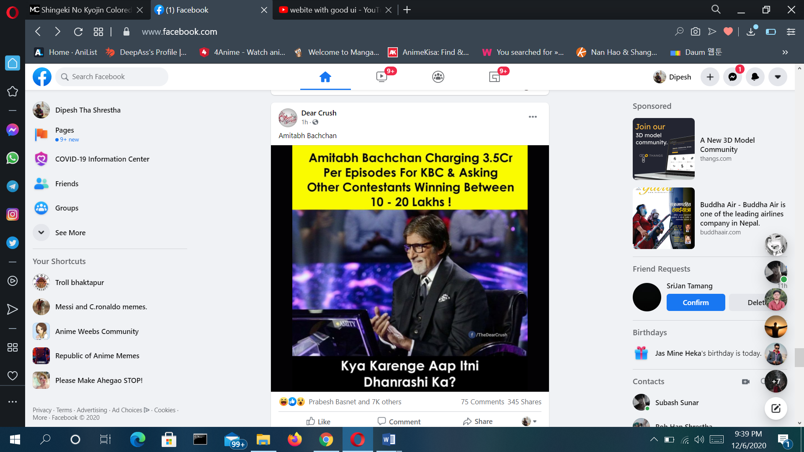

​​“Photo of the Facebook UI page”

## **3. Better Readability and Engagement**

Clean and bright designs make it easier to find the information users are looking for without getting overwhelmed and distracted. If your primary focus is to get users to read and absorb content on your site, ensure your site is appealing enough to scroll through for longer durations without readers getting tired of the user interface design and the user experience. A good UI can also encourage users to spend more time on your site and interact with more of your content, leading to higher engagement.

**Example**: Facebook, Twitter, and LinkedIn have all opted for a white background with a pastel blue to highlight anything the cursor runs over. Facebook went the extra mile and made the browsing experience richer and more convenient – it is now much easier to discern where conversations begin and end in the comments since they adopted the Messenger style bubble for comments, making threading more obvious. There is also more white space to reduce eye fatigue during long browsing sessions so the content appears more vividly.

**4. Fun, User-Friendly Icons**

The icons or buttons used to perform actions should be able to communicate their purpose clearly. While clarity is essential, be careful to not clutter your UI with too many details/instructions. Use icons that are easy to interpret and remember so users don’t feel taxed with having to learn something new and at the same time, have a visually appealing experience with clear and vivid icons.

**Example**: Facebook’s News Feed, Like, Comment, Share Notification, Feedback, Video and Marketplace buttons are bigger and easier to recognize. With a whole lot of reactions to choose from instead of the traditional ‘Like’ the user has a choice and there’s some fresh color and design added to the page. Facebook has also swapped its Notification icon from a globe to an ‘alerts bell’ for it to be less distracting, letting the user focus on content.

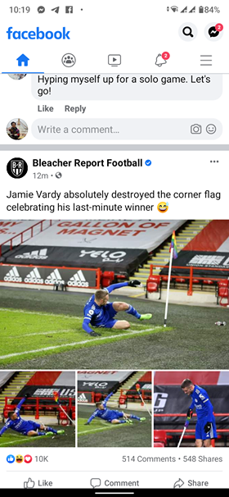

“Photo of the Facebook UI Mobile application”

**5. Personalized Experiences**

When we meet someone in real life, the way we interact with them depends on whether they are friends of friends, acquaintances, or colleagues. Why should it be different in the world of social networks? If you meet someone new, you would want to know what you have in common, try to understand their interests and find out if you have mutual friends. These social networks give you a contextualized view of profiles depending upon whether they are friends or strangers.

**Example**: If a stranger connects to you, or you browse a stranger’s profile, it displays your mutual friends (if any), basic profile information (subject to user’s privacy settings). Also, depending on privacy settings, you can browse through their photos and shared posts to get to know them better.

**Instagram: Bad UI**

Although it is the same social site designed by Facebook creator, the features are quite different which is the reason I have chosen it as a bad UI design webpage. It is not very different from Facebook because the purpose of the page is the same i.e. social site. But it misses a lot of usability principle which may also be the reason this has not as much as users that Facebook has.

Basically, the UI is for the surfing of posts or contents, viewing others' stories, chats and video chats, etc. But the good thing about Instagram is that the UI is not as complex as Twitter.

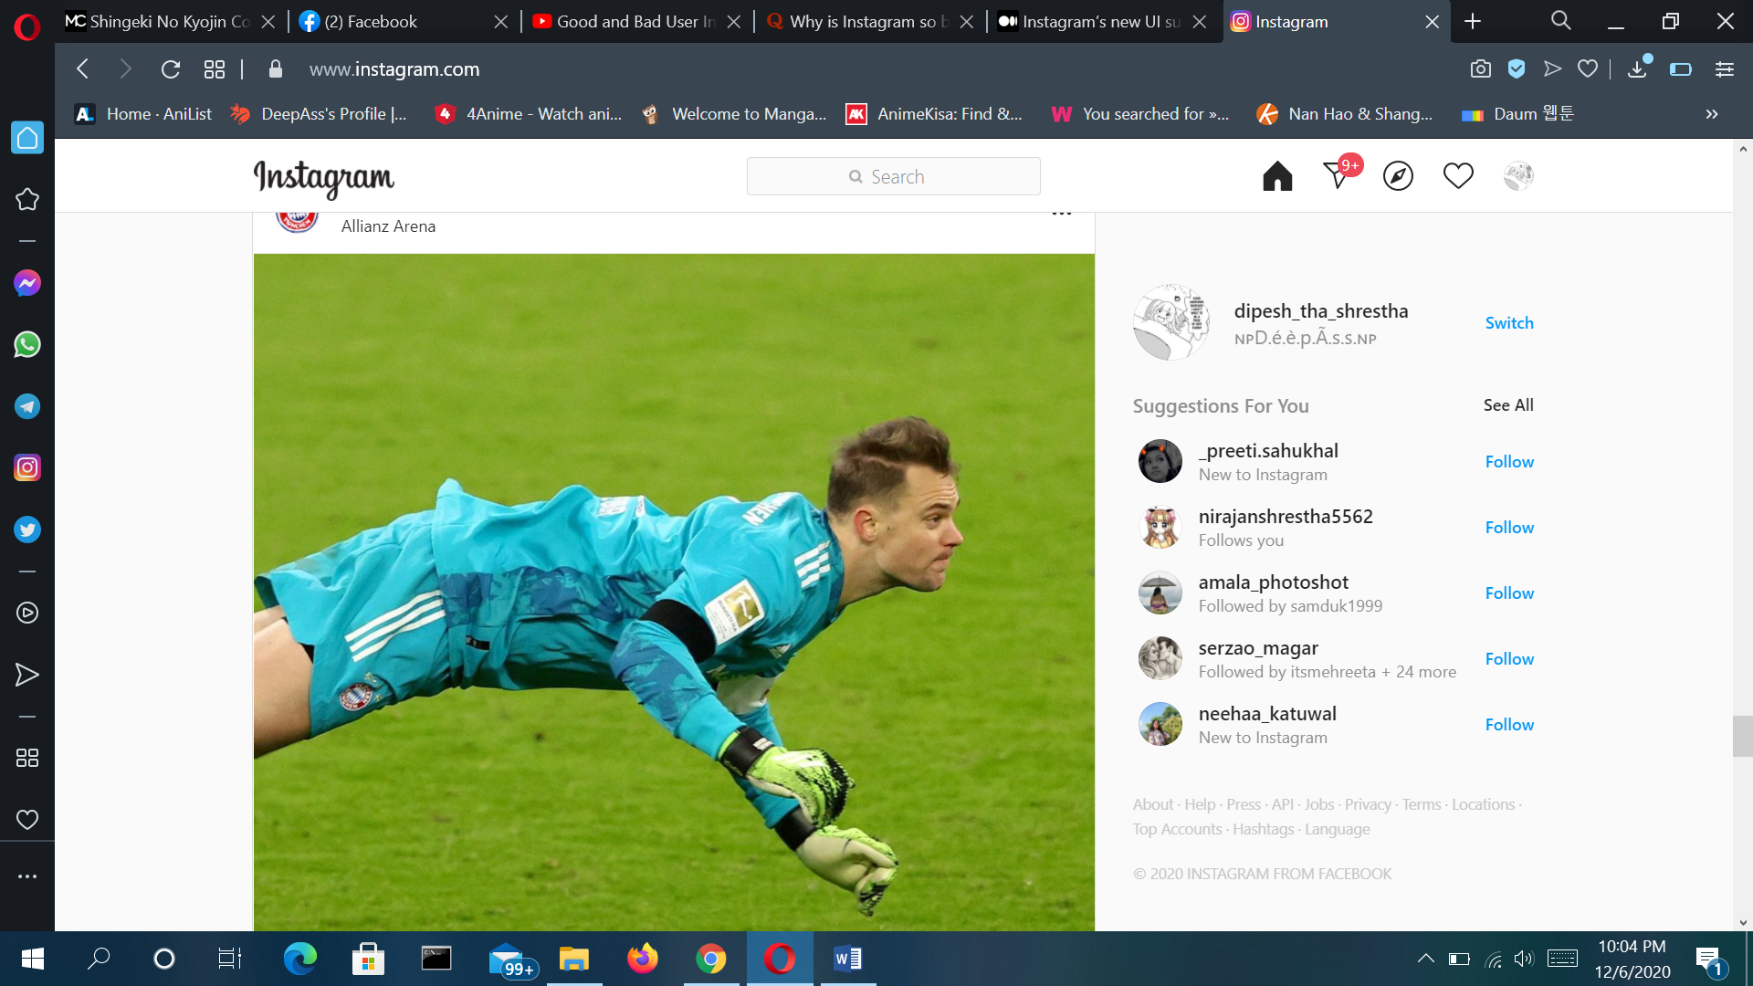

“Photo of the Instagram UI page”

Some points on why it is a bad UI

i)Some of the contents which appear on the single page don't fit. This is a bad UI design for sure because the user has to scroll down to see the same post. As we can see in the content below the same post has to be scrolled to view it fully.

ii)The UI misses the feature to let the user restart the video they are watching. There is no option to watch the video on different timings although it contains video contents which make it useless.



“Photo of the Facebook UI Instagram application”

iii) Another feature it lacks is slow or not good enough optimization of the UI. Sometimes the UI doesn’t even load even when the webpage has already loaded. And this is not due to the internet connection of the user, it has to be the under optimized UI of Instagram.